Banking Data Analytics Platform

Project Overview
A comprehensive Power BI solution for banking analytics that transforms raw transactional data into actionable insights for decision-makers across retail banking, risk management, and operations departments.

Project Details
Project Name: NexusBank Analytics Platform
Business Objective: Monitor banking performance, identify growth opportunities, mitigate risks, and optimize operations
Target Users: Branch Managers, Risk Officers, Product Managers, CXOs
Data Sources:
- Customer demographics & segmentation
- Account transactions (deposits, withdrawals, transfers)
- Branch performance metrics
- Loan portfolio data
- Credit risk indicators
Technical Stack:
- Power BI Desktop (DAX, Power Query)
- SQL Database (Source)
- Power BI Service (Deployment)
- Row-Level Security implementation

Dashboard 1: Executive Overview Dashboard
KPIs:
- Total Deposits (Current vs Previous Month)
- Total Loans (Current vs Previous Month)
- Net Interest Margin (NIM)
- Customer Growth Rate (Monthly)
- Non-Performing Assets Ratio (NPA %)
- Cost-to-Income Ratio
- Customer Satisfaction Score (CSAT)

Layout Design:
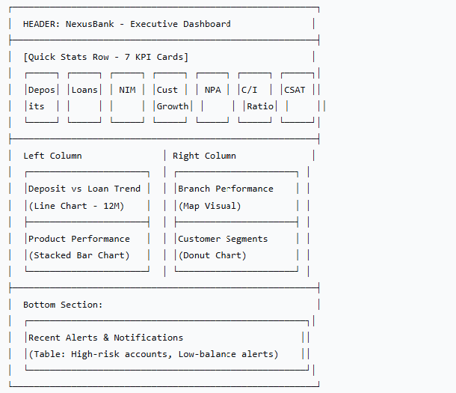
Dashboard 2: Customer Analytics Dashboard
KPIs:
- Active Customers (30-day window)
- Average Balance per Customer
- Customer Churn Rate (Monthly)
- Customer Lifetime Value (CLV)
- Cross-Sell Ratio (Products per Customer)
- New Customer Acquisition (Monthly)
- Digital Adoption Rate
Layout Design:
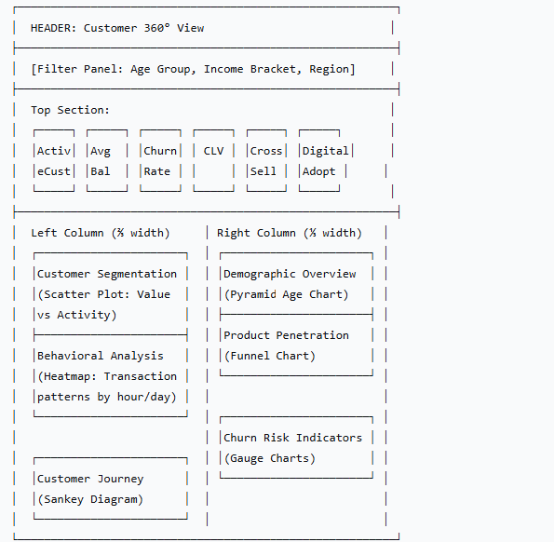

Dashboard 3: Transaction Monitoring Dashboard
KPIs:
- Total Transaction Volume (Daily)
- Average Transaction Value
- Failed Transaction Rate (%)
- Fraud Detection Rate
- Peak Hour Transaction Volume
- Channel Distribution (Mobile/Web/Branch/ATM)
- Transaction Success Rate
Layout Design:
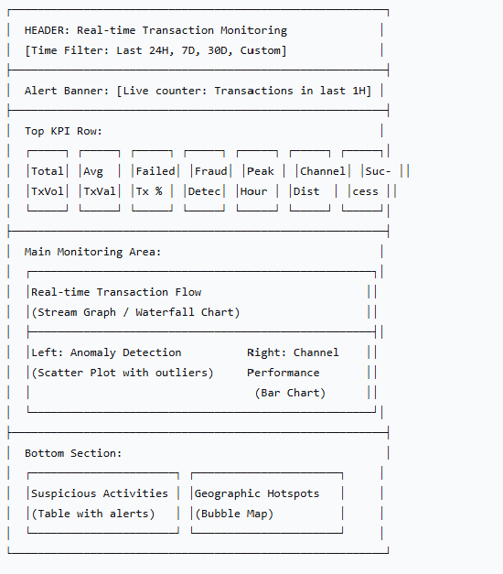

Dashboard 4: Risk & Compliance Dashboard
KPIs:
- Portfolio at Risk (PAR > 30 days)
- Provision Coverage Ratio (%)
- Capital Adequacy Ratio (CAR)
- Credit Concentration Risk
- Transaction Fraud Rate (%)
- AML Alert Resolution Rate
- Stress Test Results

Layout Design:
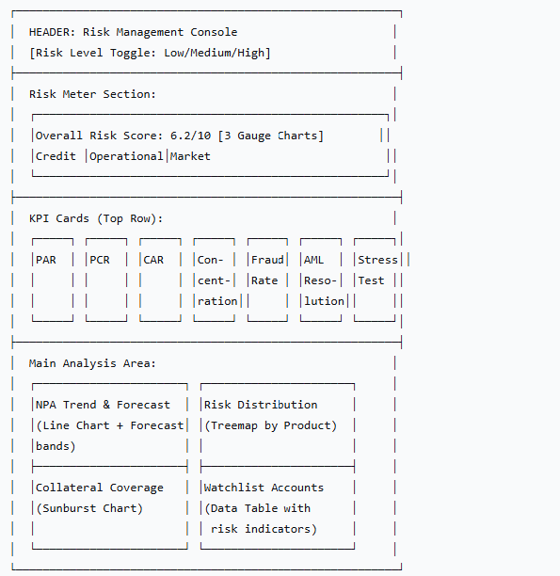
Dashboard 5: Branch Performance Dashboard
KPIs:
- Branch Efficiency Score
- Customer Footfall (Daily Average)
- Transaction per Employee
- Service Wait Time (Minutes)
- Cross-sell Success Rate (%)
- Customer Satisfaction (Branch-level)
- Cost per Transaction

Layout Design:
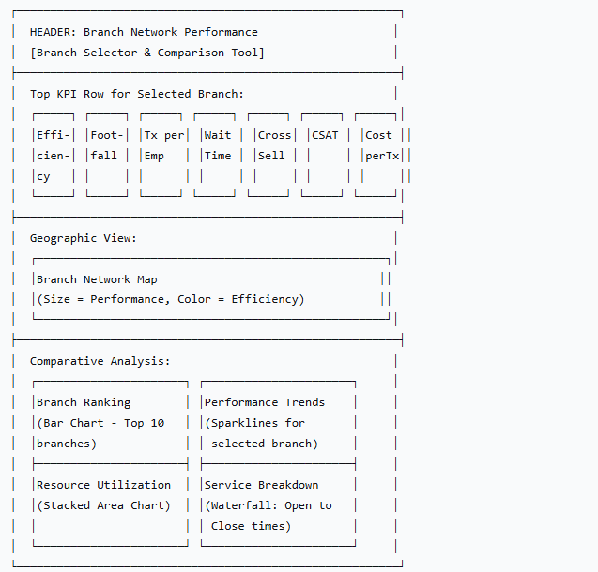

Implementation Roadmap
Phase 1: Foundation
- Data modeling in Power Query
- Create star schema with fact/dim tables
- Establish relationships and DAX measures
Phase 2: Core Dashboards
- Build Executive and Customer dashboards
- Implement row-level security
- Create calculated columns and measures
Phase 3: Advanced Features
- Transaction monitoring with real-time features
- Risk dashboard with predictive elements
- Branch performance with comparative analytics
Phase 4: Deployment
- Publish to Power BI Service
- Configure scheduled refresh
- Set up alerts and subscriptions
- User training and documentation
Phase 5: Optimization
- Performance tuning
- User feedback incorporation
- Additional custom visuals as needed

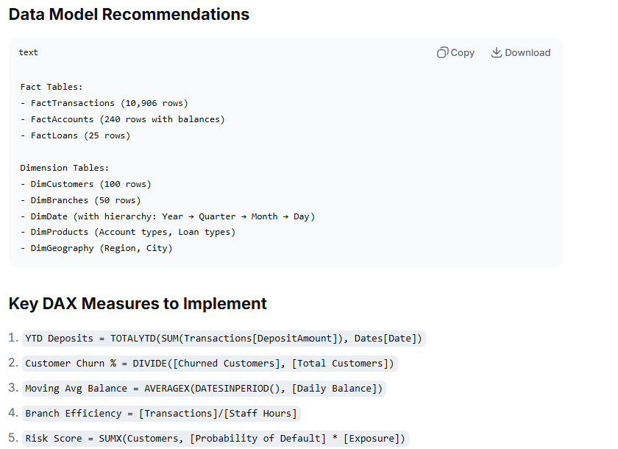

Powerquery Steps
// 1. Load your 5 CSV files
// 2. Create Date table (essential for 10K transactions)
DateTable =
let
StartDate = #date(2023, 1, 1),
EndDate = #date(2024, 12, 31),
Count = Duration.Days(EndDate - StartDate),
Dates = List.Dates(StartDate, Count, #duration(1, 0, 0, 0)),
#"Converted to Table" = Table.FromList(Dates, Splitter.SplitByNothing(), {"Date"}),
#"Changed Type" = Table.TransformColumnTypes(#"Converted to Table",{{"Date", type date}}),
#"Insert Year" = Table.AddColumn(#"Changed Type", "Year", each Date.Year([Date])),
#"Insert Month" = Table.AddColumn(#"Insert Year", "Month", each Date.Month([Date])),
#"Insert Month Name" = Table.AddColumn(#"Insert Month", "Month Name", each Date.MonthName([Date])),
#"Insert Quarter" = Table.AddColumn(#"Insert Month Name", "Quarter", each Date.QuarterOfYear([Date])),
#"Insert Day of Week" = Table.AddColumn(#"Insert Quarter", "Day of Week", each Date.DayOfWeekName([Date]))
in
#"Insert Day of Week"

